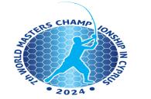

**7th World Masters Shore Angling Championship**

**Paphos - Cyprus**

**Species List:**

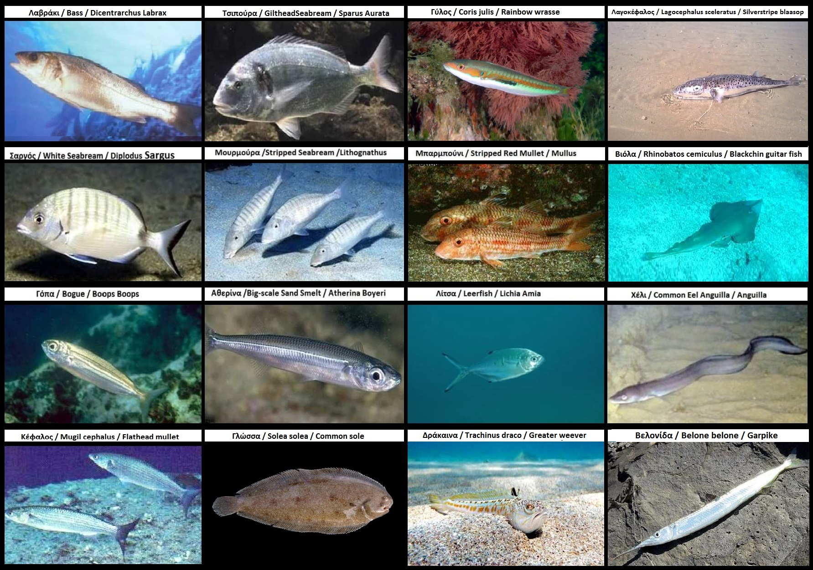

**Classification System – Fips M**

The classification system is Catch & Release (by measure)

Fish from 12cm and above get the points for their length plus 10 points

Undersized fish will be awarded 1 bonus point

**This Championship follows FIPS M Rules**

**FIPS M Rules can be downloaded at:**

<https://www.fips-m.org/statutes-rules-gb>