

**7th World Championship Shore Angling Masters**

**19th to 26th October 2024 Paphos - Cyprus**

**Travel Information**

**From Larnaca International Airport to Kissos Hotel:**

[**https://www.google.com/maps/dir/Larnaca+Airport+(LCA),+%CE%9B%CE%AC%CF%81%CE%BD%CE%B1%CE%BA%CE%B1/Kissos+Hotel,+Verenikis,+Street**](https://www.google.com/maps/dir/Larnaca+Airport+(LCA),+%CE%9B%CE%AC%CF%81%CE%BD%CE%B1%CE%BA%CE%B1/Kissos+Hotel,+Verenikis,+Street)

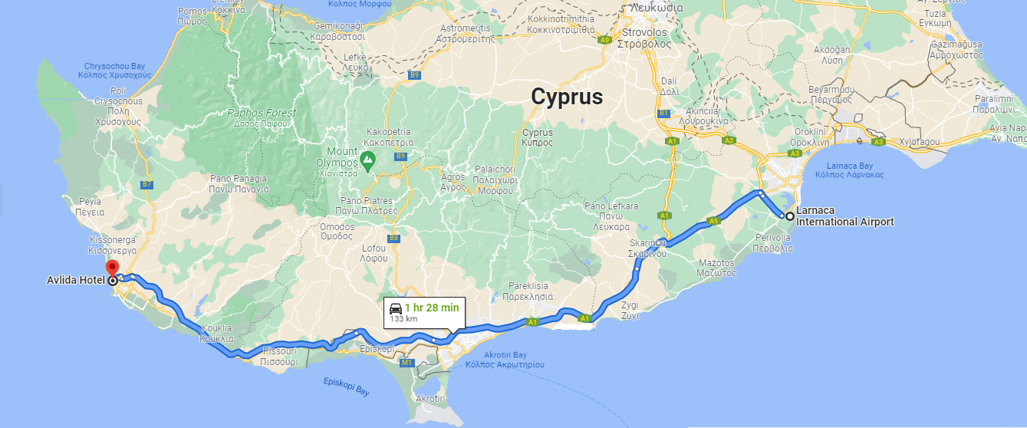

**From Paphos International Airport to Kissos Hotel:**

<https://www.google.com/maps/dir/Paphos+International+Airport,+Paphos/Kissos+Hotel,+Verenikis,+Street>

