

**7th World Championship Shore Angling Masters**

**19th to 26th October 2024 Paphos - Cyprus**

**Competition zones**

The Competitions will take place on:

**Gialia Beach - Paphos**

This beach consists of sand and pebbles. It is one of the most important beaches in Cyprus because it belongs to the Natura 2000 network. It is a European ecological network that includes areas that host natural types of habitats and habitats of species that are considered important at the European level. No services are offered.

**Informatios**: https://cyprus.terrabook.com/cyprus/page/gialias-beach/

**Distance from Hotel to Lady’s Mile Beach:** https://www.bigcyprus.com.cy/el/destinations/gialia/paralia-sti-gialia#map-anchor

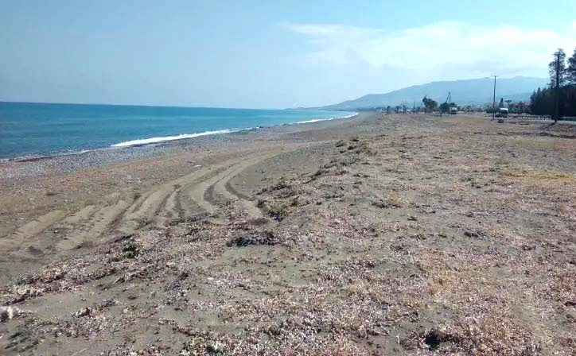 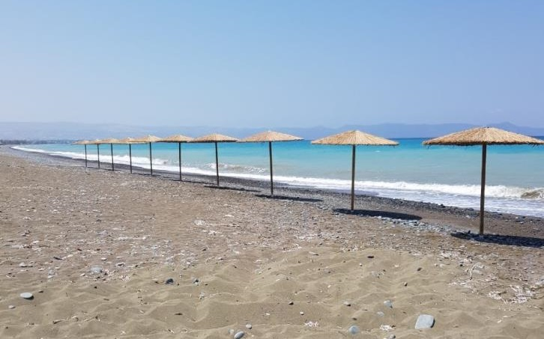

**Argaka Beach - Paphos**

Is a with crystal turquoise water and golden sand, so you don't need special shoes. The sharpness of entering the water is quite normal. This beach is suitable for different categories of people, lonely travellers, relaxation getaway lovers etc. It is not crowded place during the season.

This beach is easily accessible, it is located very close to road. Parking is located directly on the beach.

**Informatios:** <https://beachsearcher.com/en/beach/196201011/argaka-beach>

**Distance from Hotel to Argaka Beach:**  <https://goo.gl/maps/JmZx3P1RULnHYFrM9>

