

**7th World Championship Shore Angling Masters**

**19th to 26th October 2024 Paphos - Cyprus**

**Official Accommodation**

The Kissos Hotel in Pafos, Cyprus, is a three-star resort.

Enjoying breath-taking views of the Mediterranean Sea, The Kissos Hotel is only two minutes away from a sandy beach and near the UNESCO World Heritage Site of “Tombs of the Kings”. Many shops, pubs, bars, restaurants, clubs, and other amenities are just a short walk away. The largest mall of Cyprus is halfway between the hotel and the picturesque Pafos Harbour. Exciting nightlife that is closer to the Harbour and the local market are approximately a ten minutes’ walk from the resort. For the more eclectic guests, the Old Market with its chique cafés, boutique shops and many other hidden gems is only a few minutes away.

The friendly multilingual staff will ensure you a warm welcome.

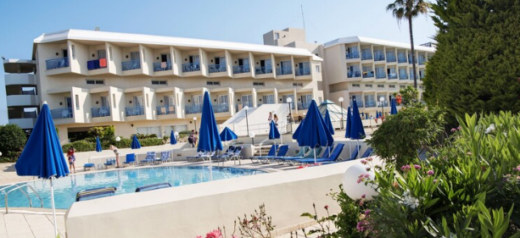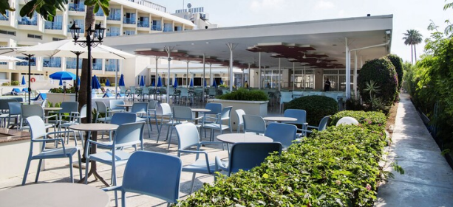

**KISSOS HOTEL**  
P.O. Box 60355, CY-8045  
Paphos, Cyprus,  
Tel: +357 2693 6111,  
Fax: +357 2694 5125,  
Email: [info@kissoshotel.com](mailto:info@kissoshotel.com)

<https://kissoshotel.com/>

