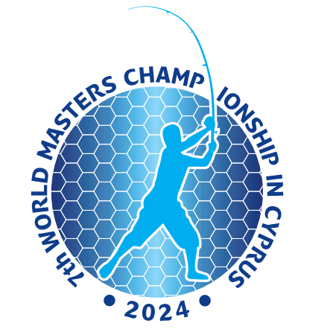

**7th World Masters Championship / 19th to 26th October 2024**

**Paphos - Cyprus**

**Οfficial Proggram**

**Saturday: 19/10/2024**

15:00 Reception of the Teams

19:00 - 21.30 Dinner Buffet Served in Semeli Restaurant

**Sunday: 20/10/2024**

07:00 - 08:00 Breakfast Buffet Served in Semeli Restaurant

10:30 **Meeting Room:** Captains Meeting

13:00 Lunch Buffet Served in Semeli Restaurant

14:45 Departure from Kissos Hotel to Paphos Towe Hall (meeting point)

15:45 Start parade of teams to Attikon Cultural Center

16:00 **Attikon Cultural Center** / Opening Ceremony

19:00 - 21.30 Dinner Buffet Served in Semeli Restaurant

**Monday: 21/10/2024**

07:00 - 08:00 Breakfast Buffet Served in Semeli Restaurant

08:15 - 08:30 Distribution of baits and lunch packs

08:45 Departure to the beach - Official Training

10:00 Entry to the Boxes

11:00 Beginning of the Official Training – Argaka beach ( Zone C)

15:00 End of the Official Training

18:00 **Meeting Room:** Establishment of the Ranking for the Official Training

19:00 - 21.30 Dinner Buffet Served in Semeli Restaurant

**Tuesday: 22/10/2024**

07:00 - 08:00 Breakfast Buffet Served in Semeli Restaurant

08:15 - 08:30 Distribution of baits and lunch packs

08:45 Departure to the Competition area

10:00 Entry to the Boxes

11:00 Beginning of the 1st Official Round – Argaka beach (Zone A)

15:00 End of the 1st Official Round

18:00 **Meeting Room:** Establishment of the Ranking for the 1st Official Round

19:00 - 21.30 Dinner Buffet Served in Semeli Restaurant

**Wednesday: 23/10/2024**

07:00 - 08:00 Breakfast Buffet Served in Semeli Restaurant

08:15 - 08:30 Distribution of baits and lunch packs

08:45 Departure to the Competition area

10:00 Entry to the Boxes

11:00 Beginning of the 2nd Official Round – Gialia beach (Zone B)

15:00 End of the 2nd Official Round

18:00 **Meeting Room:** Establishment of the Ranking for the 2nd Official Round

19:00 - 21.30 Dinner Buffet Served in Semeli Restaurant



**7th World Masters Championship / 19th to 26th October 2024**

**Paphos - Cyprus**

**Thursday: 24/10/2024**

07:00 - 08:00 Breakfast Buffet Served in Semeli Restaurant

08:15 - 08:30 Distribution of baits and lunch packs

08:45 Departure to the Competition area

10:00 Entry to the Boxes

11:00 Beginning of the 3rd Official Round – Argaka beach (Zone A)

15:00 End of the 3rd Official Round

18:00 **Meeting Room:** Establishment of the Ranking for the 3rd Official Round

19:00 - 21.30 Dinner Buffet Served in Semeli Restaurant

**Friday: 25/10/2024**

07:00 - 08:00 Breakfast Buffet Served in Semeli Restaurant

08:15 - 08:30 Distribution of baits and lunch packs

08:45 Departure to the Competition area

10:00 Entry to the Boxes

11:00 Beginning of the 4th Official Round – Gialia beach (Zone B)

15:00 End of the 4th Official Round

17:30 **Meeting Room**: Establishment of the Ranking for the 4th Official Round

19:00 **Kissos Hotel /** Conference Room / Prize Giving Ceremony

20:30 **Kissos Hotel /** Semeli Restaurant / Closing Banquet

**Saturday: 26/10/2024**

08:00 Breakfast

09:00 Departure of the teams