

**7th World Masters Championship / 19th to 26th October 2024**

**Paphos - Cyprus**

**Baits**

**1.- Coreano (3 boxes) 2.- Shrimps (3 pieces) 3.- Sardine (3 pieces)**

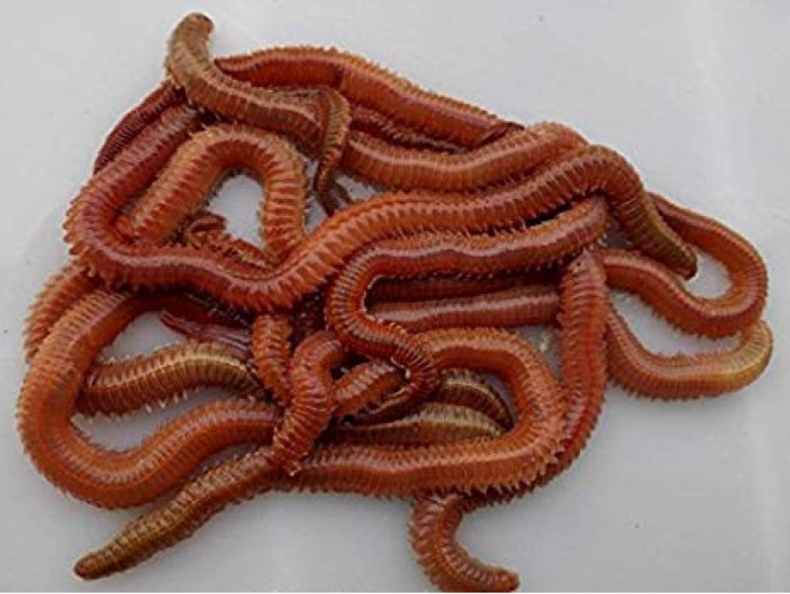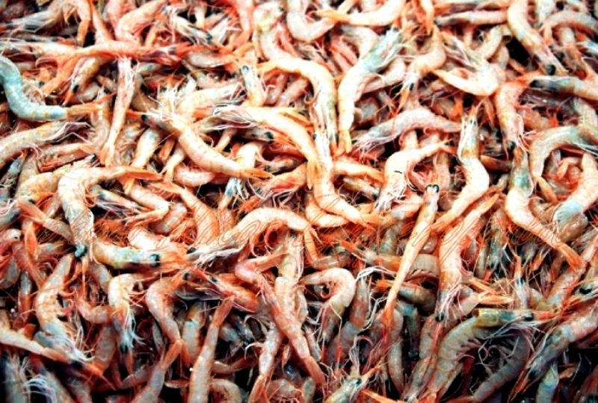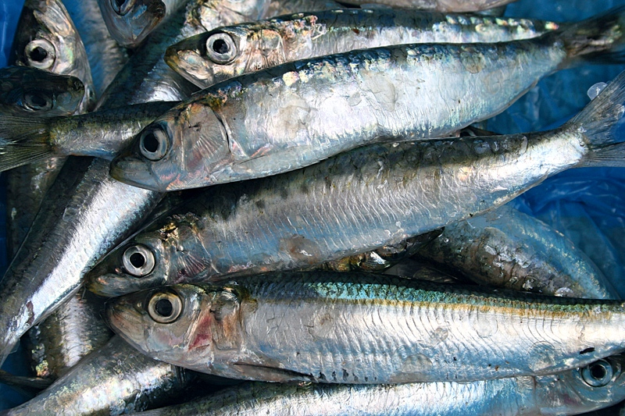

**Baits orders before championchip:**

**It is possible to reserve baits before the official competitions , in identical guantities as during the championchip, for amount 20 euro per person (3 boxes coreano + 3 pieces shrimps + 3 pieces sardines)**

|  |  |  |
| --- | --- | --- |
| **Baits Order** | | |
| **Baits Package 3 boxes coreano + 3 pieces shrimps + 3 pieces sardines** | **Price** | |
| **20 euro** | |
| **Total** | **Quantity of Packages** | **Cost** |
| …………….. | …………….. |
| **Nation / Team: …………………………………………………………………………………………………………………….** | | |
| **Receipt date from the Hotel** | ………………………….. | |

**Bank transfer to :**

**KYPRIAKI OMOSPONDIA ATHLITIKIS ALIEIAS THALASSIS**

ANDREA ASSIOTI 4 – 2007 STROVOLOS NICOSIA CYPRUS

**IBAN: CY64014001010101010024317013 BIC/SWIFT: CYDBCY2N**

**The forms and the receipt of payment must be send before July 15th 2024 to: Cyprus.s.f.c@gmail.com**